Analysis of Genetic Variation in the Rocky Mountain Horse

E. Gus Cothran and Steve Autry
July 16, 2015

Preservation of genetic variability is the key tenant of biological conservation. Within domestic animal breeds, loss of genetic variability is usually due to small population size (genetic drift) and/or inbreeding. Both processes can lead to the accumulation of deleterious recessive alleles and result in a loss of fitness and vigor or lead to specific genetic diseases. Additionally, intense selection for specific characteristics can lead to genetic fixation of the genes in the region surrounding the area coding for the trait. Again, this can lead to the increase of deleterious genes if such genes are in this chromosomal region. An understanding of how genetic variation within a breed is changing can lead to the development of management strategies to reduce the rate of loss of variation. This study was undertaken to examine levels of genetic variation (estimated as observed heterozygosity) over time in the Rocky Mountain Horse.

The Rocky Mountain Horse is a land race breed. It a subset of a larger group of gaited Appalachian mountain horses which have historically contributed to the development of a number of important American equine breeds including the American Saddlebred, Tennessee Walking Horse, Rocky Mountain Horse, and Mountain Pleasure Horse.

Rocky Mountain Horses claim ancestry to a founding stallion known as “the Rocky Mountain Horse.” This horse was reportedly imported into Kentucky from the Rocky Mountains in 1890 and became a favored breeding sire near the area of Stout Springs. Offspring from the “Rocky Mountain Horse” were known for their willing temperament, durability, and smooth lateral four beat gait. Tobe, a stallion descendent of the original Rocky Mountain Horse is on the pedigrees of many Rocky Mountain Horses.

The Rocky Mountain Horse Association was founded in 1986 to conserve the Rocky Mountain Horse. At that time the there were 33 horses identified as Rocky Mountain Horses. By January 1987 there were a total of 75 horses in the RMHA registry. RMHA Foundation stallion books were kept open until 1987. 75 stallions were in the RMHA registry at the time of closure. Foundation mare registry books were closed in 1989. There were 369 mares in the RMHA registry at the time of closure.

A RMHA grade mare program was established in 1989. The grade mare program originally accepted mares meeting the same conformational and gait criteria as foundation mares. Grade mares were not registered as Rocky Mountain Horses but were certified to breed. Male off spring of grade mares must be gelded. Female grade mare offspring who meet RMHA conformational and gait standards can be fully registered as Rocky Mountain Horses. The grade mare program was modified in 1994 to mandate one registered and certified Rocky Mountain Horse parent. The grade mare program ended in 2004.

In 1996 there were 4,310 Rocky Mountain Horses. By 2006 there were 14,630 Rocky Mountain Horses, over a three fold increase in herd size in ten years.

In 2006 the RMHA identified 1,080 stallions, 4,144 mares, and 1,121 certified grade mares in their registry. 2006 RMHA foals numbered 1,013. Grade mare offspring accounted for 137 or 14% of the total 2006 foal crop. This information was not provided for the period since 2006.

For this new study of genetic variation in the Rocky Mountain Horse, genetic variability estimates were based upon data from DNA Typing that was done for registration purposes for the breeds. All typing was done at the Equine Parentage Testing and Research Laboratory at the University of Kentucky. To examine changes in genetic variation in the breed over time we calculated average variability levels of all individuals born in the same year (an age or year of birth cohort) and compared those to values for individuals born in different years. The DNA data covers the years 1980 to 2014 (36 cohorts). The earliest year of birth cohort includes individuals born in 1980 or before due to the small numbers of horses from this time period that have been DNA typed. All data supplied by the registry was used in the analysis (17,533 individuals).

Genetic variation was calculated as observed heterozygosity (Ho) which is the actual number of loci that are heterozygous per individual. The panel of genetic marker systems used for DNA testing changed after 2006. Up until 2006, a panel of 12 autosomal equine microsatellite systems was used. After 2006, one of the loci from this initial panel was dropped and five were added. The DNA typing analysis used the 11 autosomal loci common to both parentage testing DNA panels.
Ho was averaged over each year of birth cohort and linear regression analysis was used to determine the rate and direction of change in Ho through time. In addition to Ho, variability measures calculated for each cohort were unbiased expected heterozygosity (uHe) which is the proportion of heterozygous loci predicted based upon allele frequencies and Hardy-Weinberg Equilibrium Theory and corrected for sample size, and effective number of alleles (Ae) which is a measure of allelic diversity. In order to test the pattern of genetic diversity changes throughout the years and generations, we randomly divided the individuals from the same cohort year into blocks. Each block contained at least 50 individuals. For the generation-based comparison we assumed an average generation interval of 10 years.

We applied both ANOVA and Each Pair Student’s test to compare the means of genetic diversity indices among years for each horse group separately as well as among generations. For the nonparametric analysis, we used Kruskal-Wallis test to compare genetic diversity indices among years as well as among generations. Each Pair Wilcoxon method was also used for the comparison among generations. Finally we tested the correlation between genetic diversity indices and years using Pairwise Correlation and Spearman’s method. All of these tests were done using JMP® Pro.10, SAS Institute Inc.

Results

Measures of DNA variation for the different RM year of birth cohorts are given in Table 2. Within the RM, there was a very clear and highly, statistically significant trend for Ho to decrease over time. Figure 1 shows the plot of mean Ho against year of birth. Also on this plot is the predicted Ho for each year based upon the linear regression analysis. The percent change in Ho over the time period covered here based upon the regression is 6.2%. This is roughly a period of nearly three generations so that change per generation was about 2.1%. Both uHe and Ae showed similar patterns. Plots of all variables versus year of birth are shown in Figures 2-7.

Discussion

The Rocky Mountain Horse breed had a small founding population size and has been maintained with a relatively small population size. From a genetic standpoint, what is important is what is termed effective population size (Ne) which basically is the number of unique genomes that contribute to the next generation. Within populations such as horses with long lives and complex population structure Ne is not an easy number to calculate. The primary factor involved in determining Ne is the ratio of breeding males to breeding females. In horses, as in most domestic species, the proportion of males to females is less than one which will lead to an estimate of Ne that is less (and often much less) than the census size. Based upon the simplest estimator of Ne which is 4Nm*Nf/(Nm+Nf) where Nm and Nf are the number of males an females, respectively, the effective population size of the Rocky Mountain Horse in 1989 when the registry was closed was 249. This is a small number. Based upon the 2006 numbers of mares and stallions the Ne is 3,427. I did not have more recent census information for this report. This is unquestionably an over estimate because it does not take into account factors such as degree of inbreeding or variance in reproductive contribution among individuals of the breed which also are significant factors related to effective population size. In fact, if the registry was completely closed in 1989, the Ne would not increase from 249 because no new genomes would have been added to the population. Despite this, mean Ho is actually well above the mean for domestic horses based upon DNA Typing data (domestic horse mean Ho is 0.726 compared to 0.751 for the Rocky Mountain Horse). Values of Ho for some breeds closely related to the Rocky are 0.74 for the American Saddlebred, 0.792 for the Mountain Pleasure Horse, 0.756 for the Missouri Fox Trotter, 0,792 for the Morgan Horse and 0.7421 for the Tennessee Walking Horse.

The DNA Typing markers are non-coding segments of DNA called microsatellites (mSats). mSats are a type of Short Tandem Repeat (STR) sequence. The variation is in the number of repeat units (in this case pairs of DNA building blocks) in each allele. This repeat structure is subject to copy errors during DNA replication which results in high variation. The mSat loci are characterized by a high number of alleles each at low frequency. Heterozygosity in mSats is based upon the high number of alleles while for protein coding loci the heterozygosity is more often due to two or three alleles. During inbreeding or genetic drift, low frequency alleles are most likely to be lost which would affect heterozygosity of mSats more than that of protein loci, even though total heterozygosity of mSats would remain higher. Ae does decline over time which shows a loss of genetic diversity similar to the loss of Ho.

The rate of loss of heterozygosity that is generally considered to be an acceptable one within the conservation biology community is 1% per generation. This is based upon the understanding that loss of heterozygosity is inevitable within a small, closed population. With a rate of loss of 1% there is sufficient time for natural selection to remove most of the deleterious mutations that exist within all populations mainly as recessive alleles as they are exposed by becoming homozygous. The expected rate of loss of heterozygosity based upon Ne [which is derived from the equation H_{t}=H_{t-1}(1/4Ne)] from the 1989 estimate would be 0.1% per generation. The actual rate of loss of heterozygosity over the time period of this study based upon the linear regression was 6.2%. This time period of 30 years is approximately 3 generations if the commonly accepted generation interval of 10 years is used. Thus the rate of loss of heterozygosity was 2.1% per generation. This value is above what is considered safe for endangered species but not greatly so. For a domestic breed, because human selection can be more effective at controlling deleterious recessives than natural selection, a value of about twice that for endangered species is frequently considered safe. For the Rocky Mountain Horse this means that the breed is right at the edge of the presumed acceptable rate of loss of variation. Careful monitoring of the breed will be important because the possibility of a hereditary defect appearing in the breed due to the increase in homozygosity will increase if the rate of loss of heterozygosity continues at the current rate.

The comparison of expected rate of loss of heterozygosity to actual rate of loss indicates that the effective population size of the Rocky Mountain breed is actually much smaller than what was estimated from the census numbers. The Ne based upon rate of loss of heterozygosity is only 11.9. This number is derived by solving for Ne using the equation above and the observed loss of heterozygosity per generation of 2.1% [i.e, Ne=1/(.021*4)]. This very small effective size estimate is most likely due to the combination of the high degree of relatedness among individuals and a high difference in the numbers of offspring produced by a small sub-set of the stallions compared to the total number of stallions within the breed. Relatedness means that the individuals that are reproducing are contributing basically the same genomes to the next generation and the variance in the reproductive success of a small sub-set of males compared to the total number of males will have the same effect. Because effective population size is the number of unique genomes contributing to the next generation, these factors combine to reduce Ne. A similar study of change in variation in the Standardbred breed showed an estimate of Ne for the trotter segment of the breed (which registers over 5,000 foals per year) of approximately 17.

The results of this study that covers horses born up to the year 2014 do not differ greatly from those of the previous study that covered up to 2005. Genetic variability of horses born in 2014 is lower than those for horses born in 2005 or before as would be expected by the trend of loss of variability. However, there is some reason to hope that the long term trend that has been observed over the total time period of 30 years. In Figure 1 the variability measure are not changing as fast for the most recent years as they had been in earlier years. The variation levels have been essentially unchanged from 2006 to 2014 with the exception of the years 2008 and 2010 Also, the overall rate of loss of variability as estimated in 2015 is less than was estimated previously in the 2006 report If you calculate the rate of loss from 2005 to 2013 the value is 0.73%. If these rates can be maintained, the genetic future of the Rocky Mountain Horse will be reasonably stable with lowered risk of potential genetic problems.

More work is needed to fully understand the factors influencing Ne within the breed so that more concrete efforts to control the rate of loss of variation can be made. Continued monitoring of variation levels over intervals of three to five years would provide useful benchmarks for how variation is changing over time. The rate of loss of variation could be reduced by efforts to increase the number of stallions in the breeding population. Also, it is important to understand that selection either for or against specific characteristics, such as color, will increase the loss of variation, at least at those specific genomic locations where the selected genes occur. Domestic animal breeding is a balancing act of trying to produce animals that are desirable for the specific market they belong to without exhausting the genetic variation that is the basis for breed improvement and genetic health. For breeds with a small overall population size this balance is more difficult to achieve. An understanding of the dynamics of genetic diversity within the breed is a solid first step in conservation of genetic variability.

Summary

An analysis of genetic variation within the Rocky Mountain Horse over the past 30 years was undertaken to look for patterns of change within the breed over time. DNA Typing data did reveal a highly significant loss of genetic variation over the time period examined. The rate of loss was slightly above what is considered to be a safe rate of loss by conservation biologists. The loss of variation is partially explained by the small population size of the Rocky Mountain breed. However, breeding practices, such a selection for specific traits and favoring certain stallion lines, have likely accelerated the rate of loss of variation. These are common breeding practices for domestic animal breeds however, for breeds with small population numbers care must be exercised to maintain variation.
Table 1. Measures of genetic variability based upon DNA Typing of the Rocky Mountain Horse
Year of Birth | Number | Observed Heterozygosity | Predicted Heterozygosity
1985 or before | 305 | .775 | .784
1986 | 78 | .795 | .782
1987 | 67 | .767 | .780
1988 | 88 | .791 | .779
1989 | 138 | .775 | .777
1990 | 140 | .784 | .775
1991 | 141 | .781 | .774
1992 | 162 | .792 | .772
1993 | 263 | .773 | .770
1994 | 275 | .773 | .769
1995 | 383 | .772 | .767
1996 | 462 | .777 | .765
1997 | 518 | .755 | .764
1998 | 704 | .757 | .762
1999 | 765 | .756 | .760
2000 | 1023 | .762 | .759
2001 | 1105 | .747 | .757
2002 | 1328 | .753 | .755
2003 | 1361 | .764 | .754
2004 | 1252 | .750 | .752
2005 | 1229 | .750 | .750
2006 | 1122 | .744 | .748
2007 | 1035 | .745 | .747
2008 | 915 | .739 | .745
2009 | 711 | .743 | .743
2010 | 223 | .745 | .742
2011 | 548 | .739 | .740
2012 | 481 | .747 | .738
2013 | 460 | .746 | .737
2014 | 250 | .742 | .735

Figure 1. Plot of DNA Typing Ho vs Year of Birth for Rocky Mountain horses.

0.80 ˆ
‚
‚
‚ *
‚
‚ * *
0.79 ˆ
‚
‚
‚
‚ . *
‚ . *
0.78 ˆ .
‚ .
‚ . *
HO ‚ * * .
‚ . * *
‚ . *
0.77 ˆ .
‚ .
‚ * .
‚ .
‚ . *
‚ . *
0.76 ˆ .
‚ .
‚ * .
‚ * * .
‚ * .
‚ .
0.75 ˆ * *
‚ .
‚ * . *
‚ * * . * *
‚ *
‚ . *
0.74 ˆ .
‚ * * .
‚ .
‚ .
‚
‚
0.73 ˆ
+_________________________________________________________________________
1985 1990 1995 2000 2005 2010 2015

YOB

* = Mean Ho for year of birth cohort
. = Predicted Ho based upon linear regression for year of birth cohort

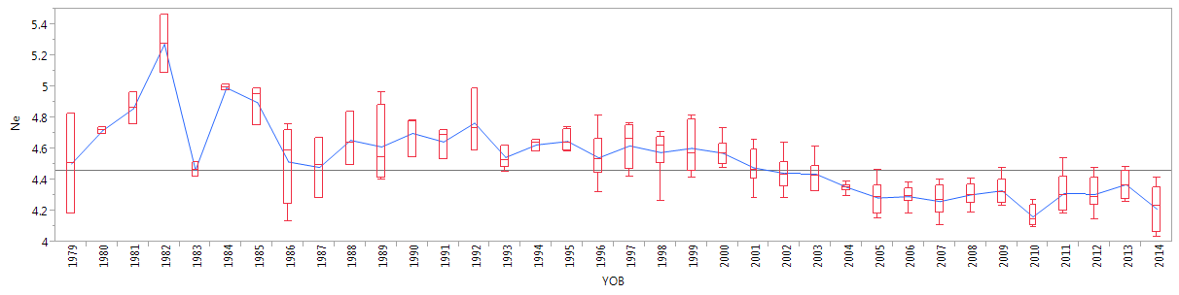

Figure 2- The effective number of alleles (Ne) throughout years

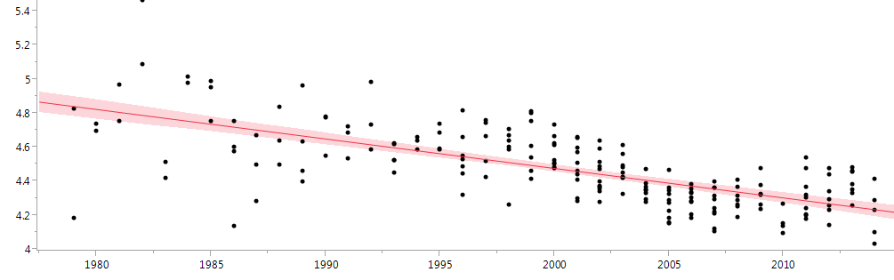

Figure 3- The correlation between years and effective number of alleles (Ne)

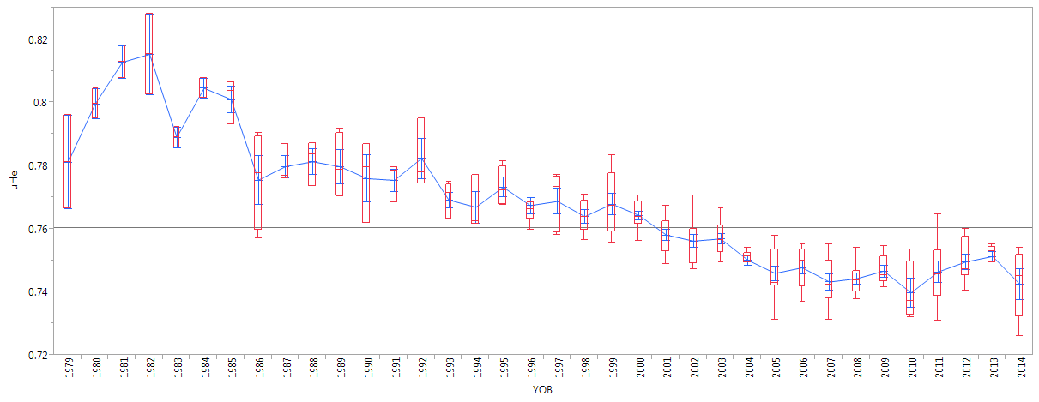
Figure 4- Unbiased expected heterozygosity (uHe) throughout years

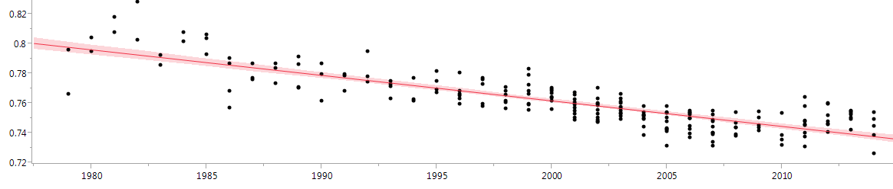

uHe

Figure 5- The correlation between years and the unbiased expected heterozygosity (uHe)

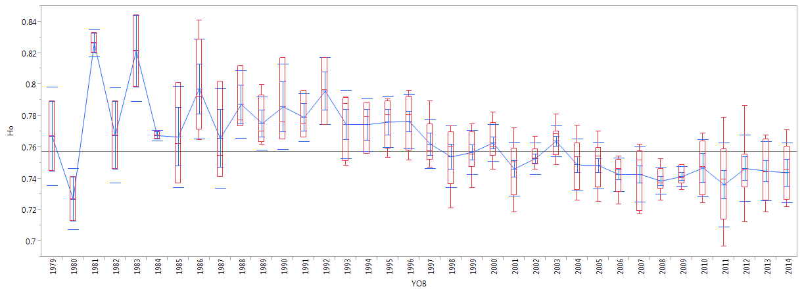
Figure 6- The observed heterozygosity (Ho) throughout years

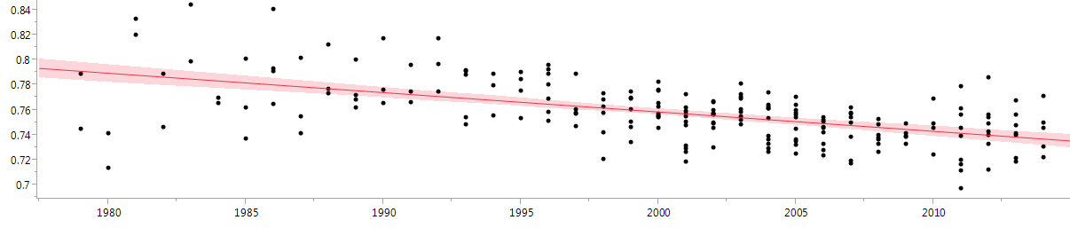
Figure 7- The correlation between years and the observed heterozygosity (Ho).

Appendix

Part 1. Recommendations
Continued monitoring of levels of genetic variation at three to five year intervals. Analysis of the data would be facilitated by making sure that Registration information for each horse is accurately contained in the genetic typing records. Whenever an error in reports sent to the RMHA from the testing lab is found this should be reported to the lab. Also, when name or registration number changes occur (as for unregistered foals that are DNA typed) these also should be reported to the lab.
Monitoring of the number of foals produced per stallion. This number is important for determination of effective population size. Also, any changes in stallion breeding patterns should be noted, especially if there is a trend for an increase in the average number of foals per stallion.
Monitoring of the percentages of coat color types within the foal crop. This will provide information relative to selection intensity for this trait.
Increase the incentives for diversity in traits. This will decrease the selection intensity.
Possible provisions for allowing registration and breeding of stallions from Grade mares should be considered. This would assist in the increase of genetic diversity, however, such stallions must meet RMHA standards and their foal crops should be closely monitored to make sure that they also meet standards.
Possible provisions for opening the registry to MPHA certified horses (if they meet RMHA standards) should be considered. This is another way to increase diversity.

Part 2. Definitions¹
Locus is the position of a gene (or other significant sequence such as a genetic marker) on a chromosome.
In genetics, an allele is any one of a number of variable DNA codings occupying a given locus (position) on a chromosome. Usually alleles are DNA sequences that code for a gene, but sometimes the term is used to refer to a non-gene sequence (a marker). An individual's genotype for that gene is the set of alleles it happens to possess. In a diploid organism, one that has two copies of each chromosome, two alleles make up the individual's genotype. These may be the same or different. Number of Alleles (Na) is the actual number of alleles observed from genotyping data. The Effective Number of Alleles (Ae) is a diversity index that is related to the contribution of alleles to heterozygosity based upon their frequency. It is calculated as (Ae=1/Σ p_{i}²) where Σ means summation and p_{i} is the frequency of the i^{th} allele.
Being homozygous for a specific gene, means that an individual carries two identical copies of that gene for a given trait on the two corresponding chromosome (e.g., the genotype is AA or aa). Such a locus or such an organism is called a homozygote.
An organism is a heterozygote or heterozygous for a gene or trait if it has different alleles at the locus for each corresponding chromosome.
Heterozygosity refers to the state of being a heterozygote. Heterozygosity can also refer to the fraction of loci within an individual that are heterozygous. In population genetics, it is commonly extended to refer to the population as a whole, i.e. the fraction of individuals in a population that are heterozygous for a particular locus or set of loci under analysis. Observed heterozygosity (Ho) is the actual proportion of heterozygotes based upon genotyping data. Expected heterozygosity (He) is that predicted by Hardy-Weinberg equilibrium, and is the value 2pq in the HWE definition below.
Genetic drift is the term used in population genetics to refer to the statistical change over time of allele frequencies in a finite population due to random sampling effects in the formation of successive generations. In a narrower sense, genetic drift refers to the expected population dynamics of neutral alleles (those defined as having no positive or negative impact on fitness), which are predicted to eventually become fixed at zero or 100% frequency in the absence of other mechanisms affecting allele distributions. Whereas natural selection describes the tendency of beneficial alleles to become more common over time (and detrimental ones less common), genetic drift refers to the fundamental tendency of any allele to vary randomly in frequency over time due to statistical variation alone. The smaller the population, the greater the significance of genetic drift.
In population genetics, the Hardy–Weinberg principle (HWP) (also Hardy–Weinberg equilibrium (HWE), or Hardy–Weinberg law), named after G.H. Hardy and Wilhelm Weinberg, states that, under certain conditions, after one generation of random mating, the genotype frequencies at a single gene locus will become fixed at a particular equilibrium value. It also specifies that those equilibrium frequencies can be represented as a simple function of the allele frequencies at that locus. In the simplest case of a single locus with two alleles A and a with allele frequencies of p and q, respectively, the HWP predicts that the genotypic frequencies for the AA homozygote to be p², the Aa heterozygote to be 2pq and the other aa homozygote to be q². The Hardy–Weinberg principle is an expression of the notion of a population in "genetic equilibrium" and is a basic principle of population genetics.
Inbreeding is breeding between close relatives, whether plant or animal. If practiced repeatedly, it often leads to a reduction in genetic diversity, and the increased expression of negative recessive traits, resulting in inbreeding depression. This may result in inbred individuals exhibiting reduced health and fitness and lower levels of fertility. Livestock breeders often practice inbreeding to "fix" desirable characteristics within a population. However, they must then cull unfit offspring, especially when trying to establish the new and desirable trait in their stock.
In statistics, linear regression is a method of modeling (or predicting) the conditional expected value of one variable y given the values of some other variable or variables x.
¹Wikipedia 2006 was used as a source for definitions.

